**Mouse Simulator**

Ratings: 4.1

Installs: 10,000,000+

Current Version: 1.23

Developer: Avelog

Game Size: 51M

**Main Menu:**

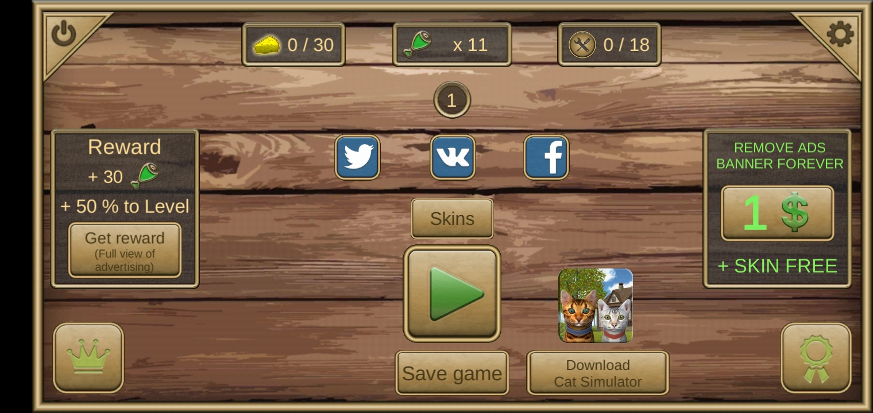

**USER RETENTION:**

To get rewards, the player has to watch an ad. The reward is kept high and attractive i.e. a 30 points increase in food and 50% level completion. Player can have the ad free version of this game in 1$ and the game also gives a free skin with this purchase. After the mouse is asleep, the game gives three options to the player. The player can either skip the banner by food i.e. 100 food points or continue the game by watching an ad and getting reward of 20 food points or remove all ads for 1$.

**FEEL AND SATISFACTION:**

The satisfaction level of this game is medium. In each level, the mouse is put to sleep automatically when the sleep bar drops which is annoying. After multiple sleeps, an ad banner occurs and the user has to wait for 8 minutes or watch and ad to skip it. The gameplay is monotonous. There are two locations but the objectives and gameplay are similar. The mouse cannot harm or defeat the predator animals that are roaming around in forest or in cottage. The concept of having a family and taking care of it is satisfactory.

**GAME DURATION:**

This game has no additional modes. After completing the tasks in forest, the gameplay jumps to a cottage. There are a total of 50 quests.

**OBJECTIVE:**

The objective of this game is to collect food for the mouse and its family and build a nest. Engage in different quests and tasks and avoid predator animals.

**REFERENCE GAMES:**

Stray Cat Simulator

Android: <https://play.google.com/store/apps/details?id=com.glutenfreegames.catsimulator>

iOS: <https://apps.apple.com/us/app/stray-cat-simulator/id969211750>

Panther Family Sim : Jungle

Android: <https://play.google.com/store/apps/details?id=com.area730.panther.sim>

iOS: <https://apps.apple.com/us/app/panther-family-sim-jungle/id1230479042>